

Department of Information Engineering and Computer Science

Bachelor’s Degree in
Software engineering

final dissertation

Autonomous Quadcopter Flight

Supervisor  Prof./Dott. Luigi Palopoli | Student  Massimo Girardelli

Academic year 2019/2020

INDEX

1 Hardware 4
1.1 Holybro X500 V2 Development Kit 4
1.2 5000 mAh Li-Po batteries 5
1.3 ROCK 4 C+ (Companion) 5
1.4 Commander computer 5
1.5 OptiTrack 5
2 Software 6
2.1 System 6
2.1.1 Ubuntu 22 6
2.1.2 Docker 6
2.1.3 ROS2 Humble 6
2.1.4 Python 3.10.12 7
55 Conclusion 7

- Abstract

This thesis is the design and development of a software application for controlling quadcopters and other flying drones.
Quadcopters have gained more attention in the past years due to their versatility and potential in various fields, including surveillance, aerial photography and transportation.
Although ready to use solutions and similar open source projects exist, an easily configurable, with a graphical interface and indoor capabilities that responds to external inputs doesn’t and this project aims to provide a working example of all these features that can be customized for different applications.
The project was developed around the ROS2 middleware and PX4 flight control software and can work in conjunction with other robots that support either of those platforms and in a modular fashion, where each component can be substituted with a similar one and expanded seamingless.
The final result is a working flying autonomous drone that can be interfaced both via software directly or through a graphical interface to perform various tasks like taking off, landing in a specific location, orbiting around a point, following a path, or be controlled manually from the pc.

Acronyms, Abbreviations and important terms

- PX4 | - PX4 is the Professional Autopilot. Developed by world-class developers from industry and academia, and supported by an active world wide community, it powers all kinds of vehicles from racing and cargo drones through to ground vehicles and submersibles.
- ROS2 | - robot Operating System version 2, middleware that enables fast and easy messages communications between different nodes on a network
- NED | - orth-East-Down coordinate system where the X-axis is pointing towards the true North, the Y-axis is pointing East and the Z-axis is pointing Down, completing the right-hand rule.
- FRD | - ront-Right-Dwon coordinate system where the X-axis is pointing towards the Front of the vehicle, the Y-axis is pointing Right and the Z-axis is pointing Down, completing the right-hand rule.
- SITL | - Software in the Loop, a simulation tool that reproduces the flight controller behavior
- LTS | - “Long Term Support”, an LTS version of software recives supports for many years to come and thus is more preferred for compatibility
- GUI | - Graphical User Interface
- OptiTrack | - Motion capture system, used to detect the drone position with a tracker
- Commander | - Main computer from where the drone is controlled
- Companion | - Single board computer mounted on the drone

1 Hardware
This is the list of components used and some reasons behind the choices that were made.
This hardware can be swapped with other alternatives, depending on the availability of the components.

1.1 Holybro X500 V2 Development Kit
Main frame of the drone, it’s a good all-in-one solution for a quadcopter, it mounts 4 920 Kv motors, perfect for this application, lower Kv motors offer more torque and less fan speed, which is desired in this application give the weight of the whole system, a higher Kv motor would strugle more.
The Pixhawk 6C flight controller offers the right connectivity that we need for this esoteric application and easily provides the CPU and RAM taht we need.

1.2 5000 mAh Li-Po batteries
- A massive 5000 mAh Li-Po battery powers the motors, the flight controller and the companion computer.
- The 4S configuration offers 14.8V, when charged it can reach 16.8V, the drone will strugle to lift below 14V.
The exact model used is: “Dinogy Ultra Graphene 4S 5000mAh 80C”

1.3 ROCK 4 C+ (Companion)
A single board computer, similar to a Raspberry PI but with a 64-bit architecture.It’s a hexacore ARM processor with 4GB of LPDDR4 RAM, which is plenty for our needs.
The GPIO PINS are used for serial communication with the flight controllerConnection is done with Wifi and a SSH shell, power is delivered via USB.
The main issue with this board is the connectivity, like many other single board computers, a big part of the I/O is connected througha shared bus and this lowers the overall throughput of data; for this particular application the network connectivity was consistently low with random spikes in latency.
The problem was not the wifi module itself because alternatives adapters and ethernet cables were used and the underlying problem was still present.
In the end the limited networking was a compromise that caued trubles in developement but the final result is almost unaffected since the system is designed to operate at a slow speed and even 100ms of delay in time the system was stable.
  - Another problem was the old operating system: the company behind this board only supported version of Ubuntu up to the version 20.04, to keep this project up to date a Docker container was used to run Ubuntu 22 and ROS2 Humble.

1.4 Commander computer
- Any computer that can run the commander programs, preferably linux with Ubuntu 22 (reasons at Chapter 2.1), alternatively a computer that can run Docker. It’s possible to use the Companion itself but there are no guarantees of recovering the system in case of disconnection.

1.5 OptiTrack
- D Motion Capture Systems mounted in the laboratory, the precision is <1 cm, latency is around 30ms, publish rate is 360Hz by default but the drone remains stable up to 50 Hz of data recieved in case of network congestion.
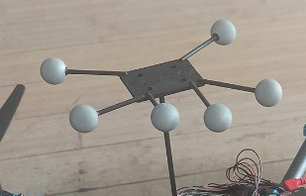Figure 1: tracking marker on top of the drone
- Tracking is done by recognition of a special tracking marker placed on the drone, each model saved has it’s own ID that will be transimmed with the data.
- The 9 cameras placed around the flying area, provide an accurate position estimation. The position is sent through the network and must be decoded by a client.
- This system is heavily dependent on a proper configuration of the cameras and a correct model of the tracking marker.

2 Software
- In this software chapter I will explain the systems and tools used to bring this project to life and the inner workings of the components to kae the drone fly.

2.1 System
- In this section I will focus on the operating system and system-wide software used, every other program suns on top of these:

2.1.1 Ubuntu 22
- This was a very important decision since every distribution of Ubuntu has it’s own ROS2 distribution and the latest LTS (for now) only supports Ubuntu 22.
- It’s possible to run ROS2 Humble on other distributions but it must be compiled from source and the chance of error gets bigger, expecially on embedded systems.
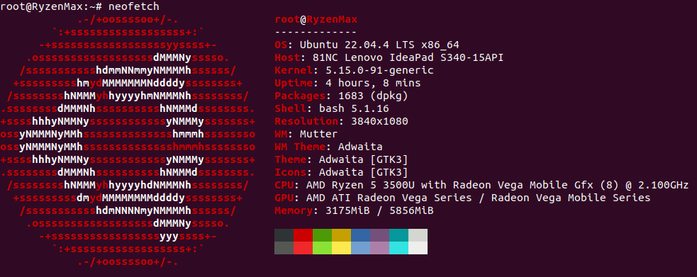Figure 2: Commander pc specifications

2.1.2 Docker
Docker is an amazing tool for virtualization and portability; with docker it’s possible to create an image of a system and run a container almost like a virtual machine.
The container has all the libraries needed to run an entire system and is widely used for compatibility since it’s possible to run a completely different operating system inside a container.
If it’s impossible to use or install Ubuntu 22 a good alternative is a docker container, like it was used for this project.

2.1.3 ROS2 Humble
Middleware used to share all messages between applications and to launch most of the applications, ROS resolves around Nodes, Topics and Messages:
- Nodes: a process interfacing with the ROS libraries, different nodes can run on different machines while being connected through networking and be visible to each other.
- Topics: a pipe-like virtual structure within ROS that can be used to share messages between different nodes, it can be interfaced as a publisher or as a subscriber, each topic routes one specific message type.
- Messages: data structures that travel through the nodes, it is not system-dependent and provides primitive types like booleans, integers, floats, arrays and nested messages types.
Custom messages were built for this projec

The optimal QoS (Quality of service) options were used:
- Best effort, to reduce network congestion, most messages are ephemeral and gets overriden a few milliseconds later, therefore if some messages are dropped it doesn’t affect the system
- Transient local: the publisher is responsible for delivering the last message tho subscribers who joined after it was published
- Keep last: only keeps the last message, previous values are invalid anyway

2.1.4 Python 3.10.12
- Python was used for the ease of development and speed of deployment as it doesn’t need compilation; python with PX4 has also much more documentation and examples than any other language.
- Other programming languages that have better performance like c++ were considered but discarded due to minimal documentation, much more developing time and a very slow overall development experience and unpleasant experience:
- • ROS2 compilations have massive overheads, even for well written cmake files while python has none;
- • a part of the code runs on the companion computer that, while powerful, is not really suited for continuous compilations
- (installing all the PX4 dependencies and building the optitrack package took more that 1 hour and a half)
- The runtime overhead of python gets completely eclipsed by the network delay.
- The version 3.10.12 is the officially supported by ROS2 Humble
- Conclusion
..,.

Bibliography
[1] Coulouris G. F., Dollimore J. e Kindberg T, Distributed Systems: concepts and Design, 1994
[2] Dalal N., Triggs B., Histograms of Oriented Gradients for Human Detection, 2005
[3] Donoho D. L., Compressed Sensing,
[4] http://www.ictbusiness.it/

